Activity No. <1.3>
<Hands-on Activity 1.3: Writing First Program using C++ Language
>
Course Code: CP007 | Program: Computer Engineering
Course Title: Programming logic and design | Date Performed:9/1/2025
Section:CPE11S1 | Date Submitted:9/1/2025
Name(s): Hanz Rhayven M. Pabalan | Instructor: Engr. Jimlord Quejado
6. Output
Exercise 4.1
Try to create a simple program using C++ language that outputs your whole name. Using the new line syntax, output your program and the course and section.

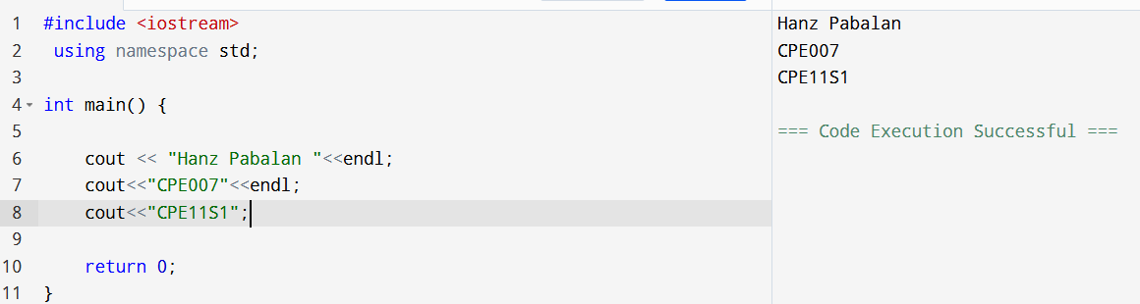

Exercise 4.2
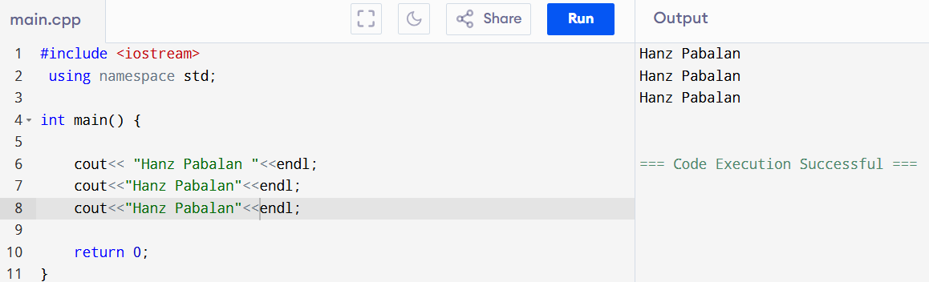
  - Check the program below. Find all possible compilation errors and logic errors. Fix them. Your version of the program must print the same result as the expected output. Before you use your compiler, try to find the errors only by manual code analysis.
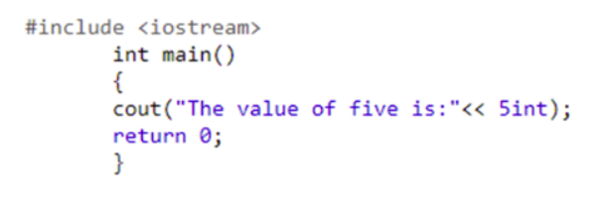
ERRORS:
- Missing “using namespace std;”
- Incorrect usage of “cout” no less than symbol
- Wrong syntax, it should be 5 only no int beside

Output:
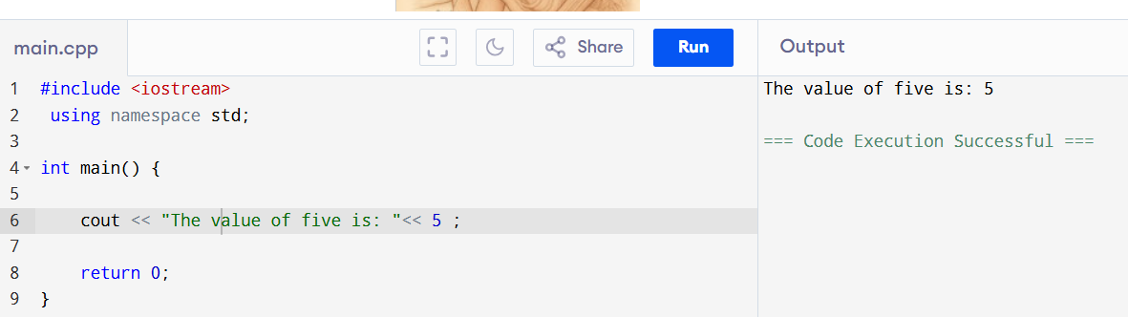

- Check the program below. Find all possible compilation errors and logic errors. Fix them. Your version of the program must print the same result as the expected output. Before you use your compiler, try to find the errors only by manual code analysis.
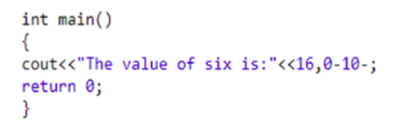
ERROS:
- No #include <iostream> and using namespace std;
- You cannot put “-“ operator
- And the only number inside should be 6 because you want to print 6
- And remove the comma
Output:
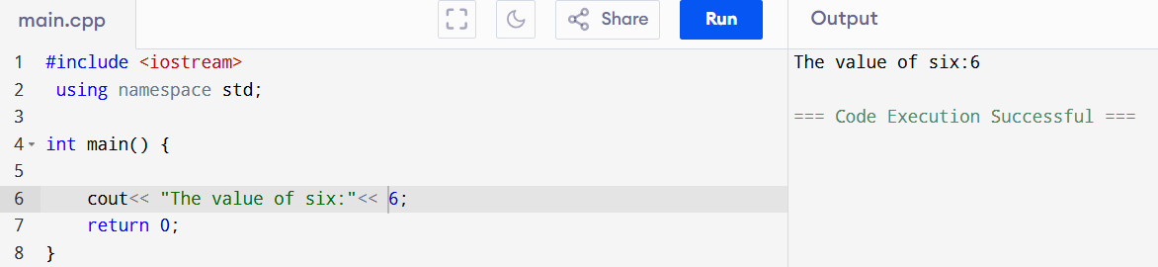

- Check the program below. Find all possible compilation errors and logic errors. Fix them. Your version of the program must print the same result as the expected output. Before you use your compiler, try to find the errors only by manual code analysis. If you want to improve the variable names, then do so, but remember that variable names have to be as descriptive as possible, and also as short as possible.
ERRORS:
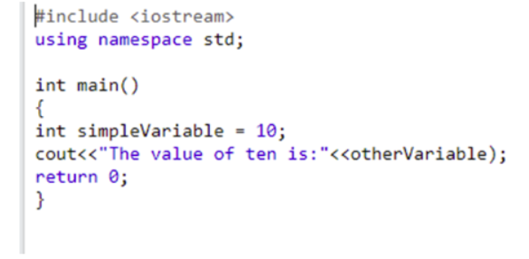
- otherVariable is not declared it should be “simpleVariable”
- incorrectly printed using an undefined variable
Output:
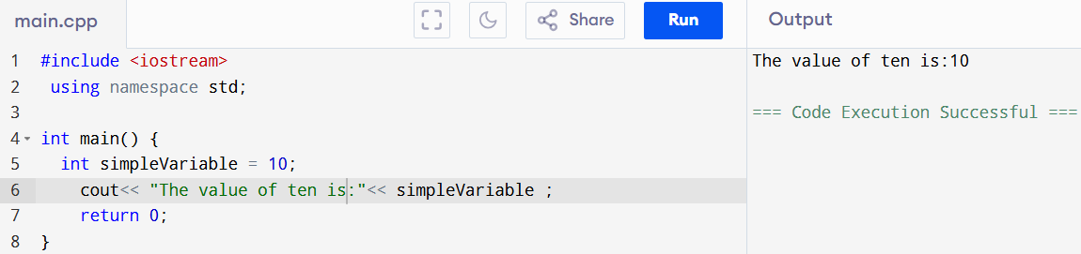

4.Check the program below. Find all possible compilation errors and logic errors. Fix them. Your version of the program must print the same result as the expected output. Before you use your compiler, try to find the errors only by manual code analysis. If you want to improve the variable names, then do so, but remember that variable names have to be as descriptive as possible, and also as short as possible.
ERROS:
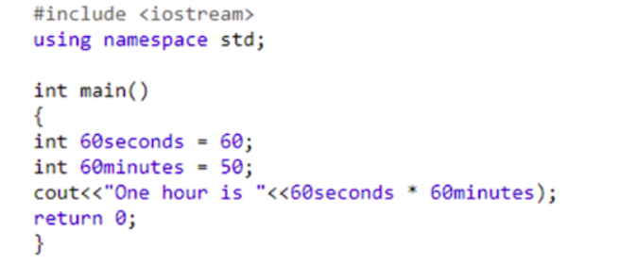
- invalid variable names, you cannot start with numbers
- it should be 60 not 50
- Expected output is "One hour is 3600 seconds", but the "seconds" string is missing.
Output:
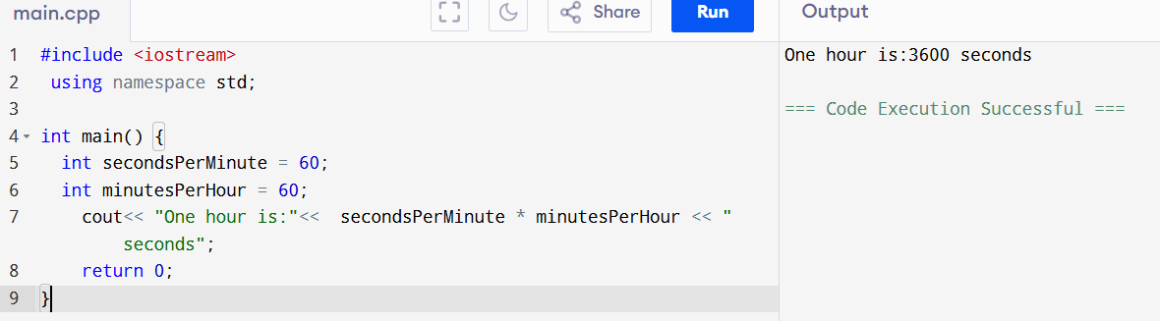

- Check the program below. Find all possible compilation errors and logic errors. Fix them. Your version of the program must print the same result as the expected output. Before you use your compiler, try to find the errors only by manual code analysis. If you want to improve the variable names, then do so, but remember that variable names have to be as descriptive as possible, and also as short as possible.
ERROS:
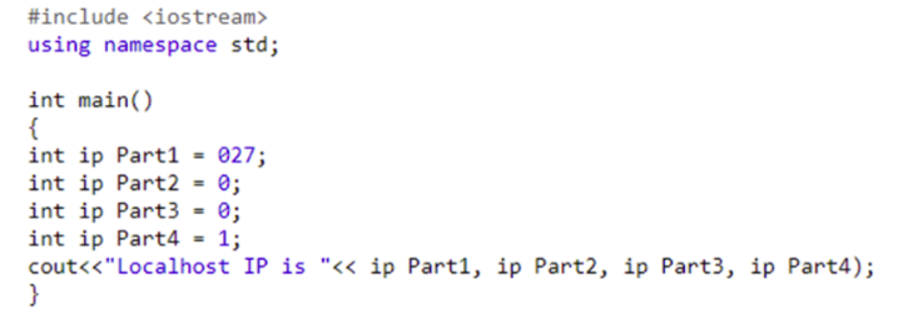

- Invalid variable names you cannot put space on int it should be “ipPart1”
- Incorrect cout syntax Commas You must use << between each value and also insert '.' between IP parts.
- You need to put 127 on part1
Output:
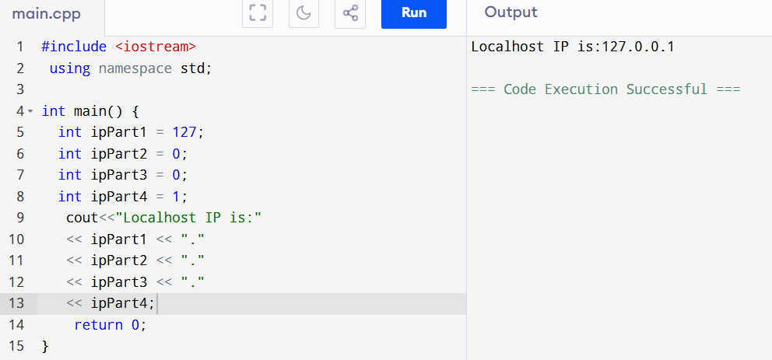

7. Supplementary Activity
8. Conclusion
It’s a challenge to see all the errors of the code at first but now I can see it fast and how to fix them correctly, but sometimes you need to stare at the error for like 5 minutes up to get the errors, but ill practice more to improve my sight skills.
9. Assessment Rubric

